Give-AID Project

Sem 3

Figure 1: Product logo

Content:

1. About the project
2. Presentation of the direction of working with the project
3. Brief introduction of the product
4. Functional details in the product and some of the things inside it

*Implementation Team:

* + - * Group : 1
      * Member: LAI NGUYEN VU, LE MINH DUC
      * Instructor: BUI DUY KHIEM (CUTE)

I.Project Introduction

1. The project was received directly from the APTECH center, this time they assigned my group the topic is to build a website about non-governmental charity donation activities, the website will have basic requirements for article creation, donation, there are 2 modules of admin and user
2. Analyze the direction for the product

1. This time, as with the other product making, the team started to come up with an idea for the product, and asked a one-page question about the charity organization that we will analyze based on the 2 modules that APTECH provided.
2. About ADMIN, it is necessary to have basic functions such as creating news readings by topic, creating partners, managing user accounts, and configuration functions.

**🡪 Outgoing Flows for Functions in ADMIN 🡨**

Article:

Create a new article: an article needs to have a title, image, content, target amount because we do the topic of donation, the type of article type of article will tend to be tagged by topic so that users can easily visualize, describe it generally, partner for the article explain a little more carefully partners here, my group follows the model The partners will be the contact for the GIVE-AID admin to create the post, the partners will usually be charitable foundations or benefactors or some other spontaneous organization if they want to raise funds for charity, and the last one is to choose a deadline for the post.

Create a category for the article: I can create a new type of article before posting it in case I want to tag that article separately because the donation article has many different topics.

List of articles: To create, there must be a list created many times, there will be a large number, so there will be a list to be managed, so this is very necessary, in this I will add the necessary operations with such as the button to create a new article to be ready, for re-editing the post, updating the status of the example article has not expired, but if the partner wants to stop calling or stop running the post, there should be a place to update the status of the post. In addition, the group decided not to delete the article, because there may be cases where the support money has not reached the milestone they want to repost and call for it again, or somehow, it is better to feel that not deleting the article is a very convincing reason. I know that CRUD is the basic thing of a function, but sometimes I don't need D, I can have CRU.

Partner:

🡪 Direction for partners: Talking about partners there are many genres, it can be a charity fund thanks to an appeal, or a company or a certain brand sponsoring a website in that form of advertising. It should be collectively referred to as partners.

The functionality in the partner is almost the same as the article, they will be able to upload their logo, some information needs to have an address, phone number, email, a few descriptions about the partner

Partner list: the same as the article, there will also be a list with a new create button, an edit button, update the status for each partner, in addition, it is still to remove D from CRUD only for CRU, that is, not to delete partners just to hide them.

User Management:

1. The direction is to create a list page, manage the registered accounts, in addition to the idea of updating the position of the account, and updating the status of that account here and there is another one that will lock and unlock the account so that if that account has any sabotage actions affecting the website, block them. In addition to the position of the user account, there will be 2 types, one is MOD and the other is USER. USER is just a normal type of account, they have basic rights to view and donate to articles outside the user page, MOD is a little more special, they have additional rights to create content and create new articles, they have the right to add and edit status updates for those 2 functions. In addition, other things in the admin such as account management or configuration functions are not allowed to be used, only the supreme master has full rights.

Configuration

1. The direction of this function is, if you want to make a configuration system for the website, for example, you can edit the display image and contact information, or for example, if you have an email to share an article, let them configure their email. Here's an overview of the configuration functionality that the team can think of.

Data

1. Simply want to load the data and list the necessary information for the admin to grasp, for example, make a chart, update the total number of articles, the number of completed projects, the total amount of money collected from the articles, etc. so that they have a lot of data to capture.

***\*\* Here are some of the functions that my team thinks are a must-have for an admin page and the things that our minds can and can do are \*\****

🡪 Outflow for functions in USER 🡨

Article:

The article can be viewed after the admin has successfully created it, in the article there will be information related to. Users can donate to the price selection, they can see the target amount, how much they can donate, the project progress bar, the expiration date, Share the article according to the email they enter, in addition, each article has a detail page that must be innumerable to help them read full information such as the appeal content, donate list, donate function, share articles via email, donate can be anonymous, through vnpay's payment method.

Menu:

There will be things like the Home page, Project all, the partner page, the help center page, the information page about us.

Home will mainly show the latest posts that have just been created, articles that have not expired, are donating and can be donated roughly new articles will go to home, in addition, articles that appear in home can be filtered by the type that we tag it.

The product page, as the name implies, all products are in it, and inside this is a filter, for example, it is possible to filter out which articles have expired.

The relief center is focused on viewing, here the whole group decided to view useful and reliable relief centers in the whole region of Vietnam

The partner page, which contains things related to the partner, can see each description of the partner here. The partner is created in the admin system, if that party is disabled, that partner will not be able to view it here.

The information page about us here, put some information of the web from the bottom of the footer, the rest will be the information of my group who make the product here, in the future it may change according to the consumer, but now it is our own product, so it will be our information there hehe :D

🡪The direction for the user admin to be effective, call it the name of the login / account creation / password change function / 3 functions blended together called LOGIN 🡨

**The login function was born in order for the operation between users to have a clear decentralization of permissions, the function of distinguishing the type of account using the function of the product**

Create an account:

The name says it all, creating an account will help us log in to the website and there will be some functional information that can be used. Currently, there are 3 classifications of accounts according to the strongest power level: ADMIN – MOD – USER power and function, it will go from left to right, ADMIN full function rights, this account can only be granted through my group, so if the user uses it, he must take care of the account, and MOD will be adjusted by ADMIN in the user function on the admin side of the system. Creating a new account will default to the USER type. The difference between holding MOD and USER is that ordinary users can only operate outside the user page, while MOD can enter the admin page but only give them the right to use the partner and article functions, the rest are not allowed to touch.

Log:

Using the same login portal for admin and user pages, where you go to the right corner of the website, there will be a login place to log in, depending on the type of account, the function there will be different. For example, when logging in, there will be things that can be done to view account information. It works such as updating your profile picture, changing the display name, updating your email and address, and also being able to view the history of your donated posts. You can click Change Password from this page when logging in. And logging out helps make it possible for users to use some of the typical required functions of the product. And in addition, the system page can only be accessed through login ADMIN!!.

3.Brief introduction of the product made

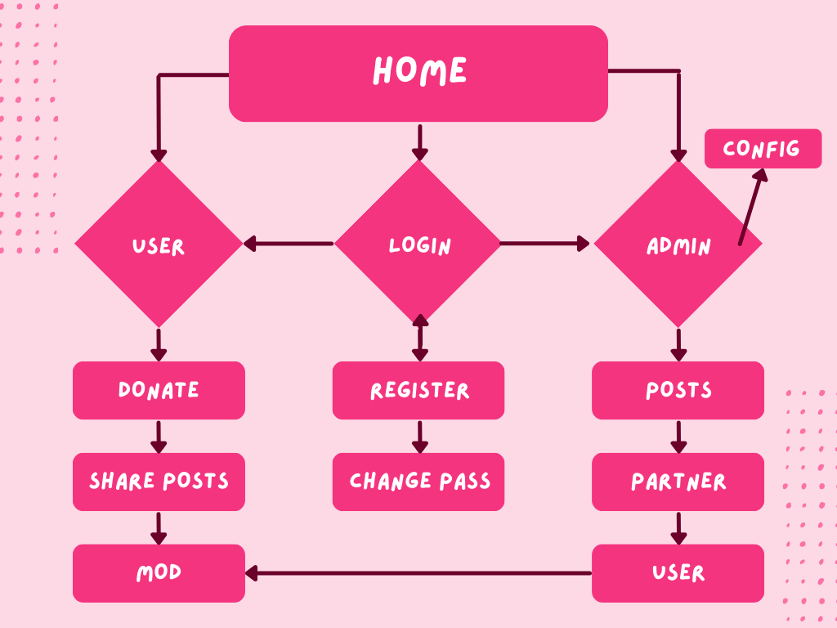 The product my team designed based on the 3 view criteria of user-login-admin, increasing the interactivity between pages, helping website managers and users to use the product without too complicated or difficult, trying to bring simplicity, but still beautiful and full functions necessary for a product.

*Figure 2 depicts the direction of the functions in the product*

4.Main functions available and running on the product

As a product used for the purpose of calling for donations, used to raise funds to support people in difficult circumstances, in addition to being just beautiful, the functions contained in it must also be simple and friendly to create an easy feeling of use for consumers. The main purpose is that the function is powerful but simple, not too many steps, the operation still brings high efficiency

I.User

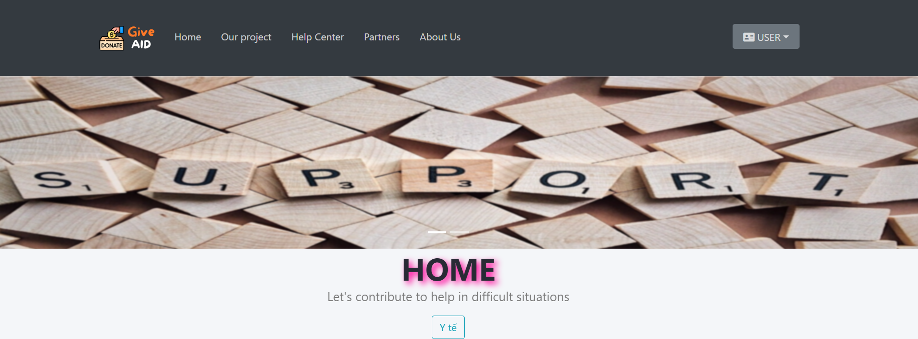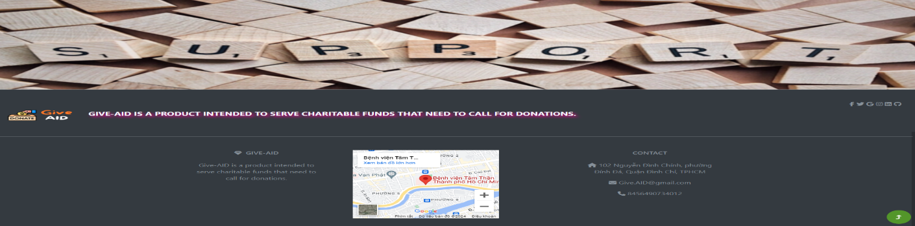 With a layout of 3 headers, there is a menu next to the product photo slides on display, 1 shaped photo, footer.



Figure 2: Description of the 3-part layout when entering the web

When you enter the website, you will see a navigation menu bar, here there will be pages where the website has a home page, which will mainly be used to view the most prominent articles, specifically newly created articles will appear here, briefly talking about why there is a slide above and a background image at the bottom of the item is to make the view at home with many pictures Photos on the topic of the donation as well as for the appeal photos to carry the good message of the website, at the bottom of the page there will be a few more contact information of the website. Going deeper into the central details of the home page, we will see that there is a small tag here that is the type that was mentioned above the direction, as it will be added at the beginning of each article so that users can identify by which topic. And in addition, when we click on that tab, it can help us filter articles by topic. And in addition, it has a pagination at the bottom, currently in Home, there will be a pagination for every 3 articles

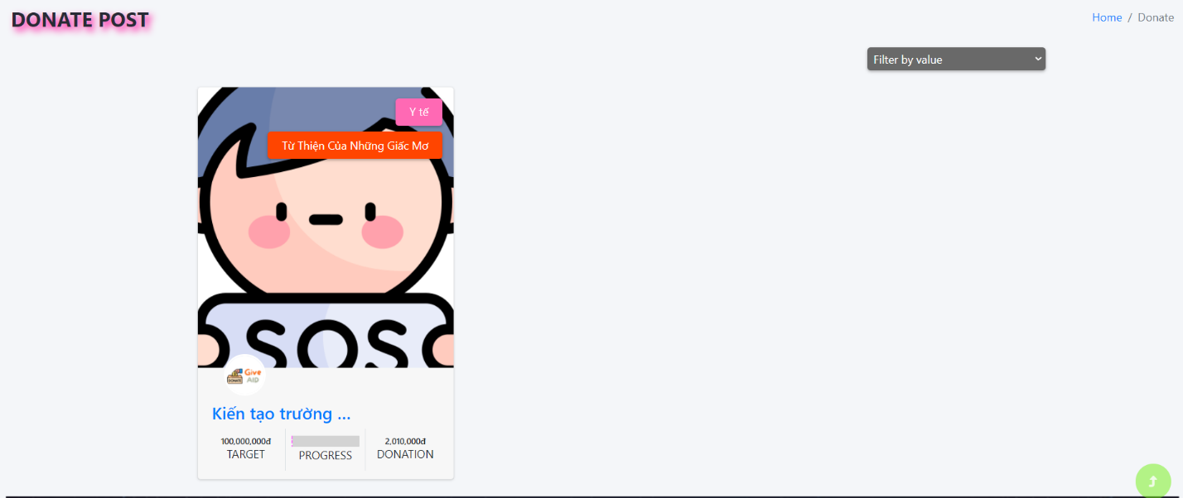Next to the homepage there will be a menu called our Project where all the Projects created will be located here with the same design as the homepage.

Figure 3. Detailed description when viewing our Project page

On this page we will see the page name in the left corner and a navigation bar to let the user know which page they are currently on. In addition, I have placed a view filter here so that users can find how the article is pre-filtered.

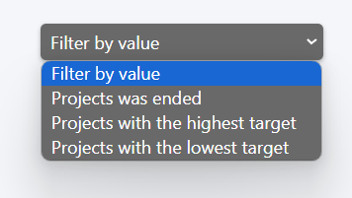

Figure 4. Filter view for our Project

Next we have a menu to go to the relief center page, here the intention is to let users when they have a problem about something they can see the information about these relief centers, here there is some information that has been recorded by the center so that they can easily contact, Also, do you make a See More button for me to go to their page if I want to know about the center, can I do anything to help them? Because I am a student from Vietnam, I only update the information here is the help centers of Vietnam.

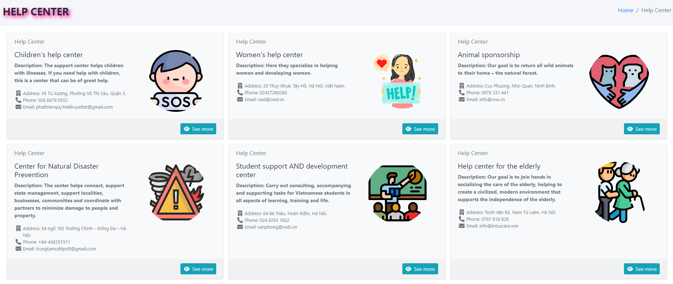  
Figure 5. Help center with detailed information and a button to go to their page to see what they have

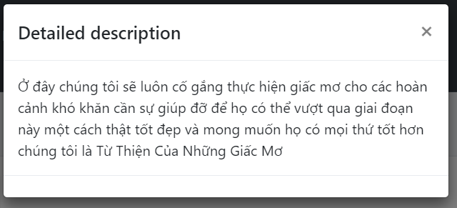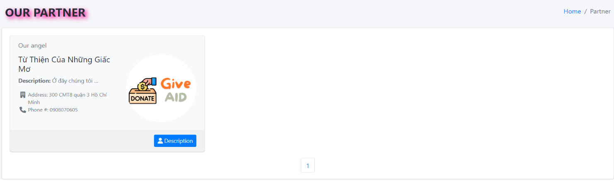Next, we have the partner page, here when we create a partner on the admin page, we will create a referral card for them on the user's page, similar to the help center page, but here instead of the see more button, we have a button that describes them to read information about them, Most of the partners here will be charitable funds they come to rely on the website to write articles for them to call for donations for a certain difficult situation.

Figure 6. Partners when created will be like a button to read their full description

Và rồi cuối cùng là trang thông tin về chúng tôi trang này chúng em chỉ cập nhật một số ít về trang web còn lại là hình ảnh mô tả về người làm sản phẩm này là nhóm của em. Ở đây chỉ có 2 thành viên làm sản phẩm là LAI NGUYEN VU và LE MINH DUC, còn XUAN CA e để vô thêm trong đây là để cảm ơn sự động viên của cô ấy, cô ấy là hàng xóm của nhóm chúng em lúc nào cảm thấy tinh thần mệt mỏi thì cô ấy đã động viên cho chúng em có tinh thần hơn để làm việc hiệu quả.

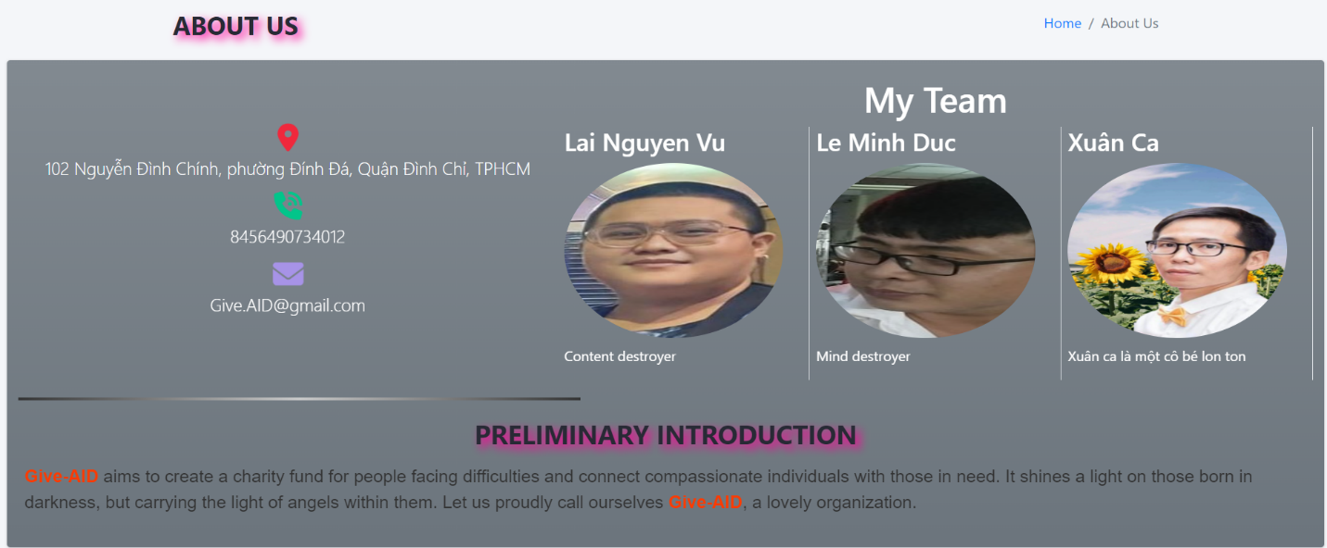

Figure 7. Describe the about us page with the information of the product maker. Xuan Ca is an honor, so it does not count as a member of the group

After all we will come to the login page from here we will have more work to do and also tell more clearly about the things that users can do at the homepage. In the right corner of the home menu there is a login menu.



Figure 8. Login Menu

When you click on it, you will be taken to the login page, here there will always be a place for us to create a new account to create an account. In addition, in the login box, you can put a small icon in the shape of a house, click back to return to the homepage or the word GIVE-AID website name to go home.

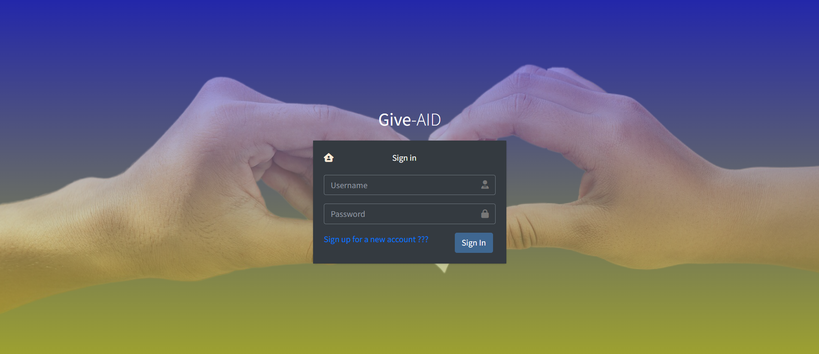

Figure 9. Login page with text on the new registration page

II. Login

There will be 2 main types of accounts: admin and user, here I will do it on the admin account first and then I will register a new one to do the operations like a normal user.

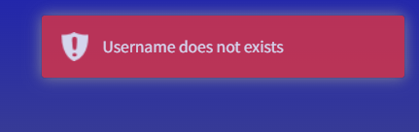And in addition, if you enter the wrong password or account, we make a small message in the right corner to warn users.

Figure 10. The corresponding error message when the user enters the wrong account or password

Then, when we have successfully logged in, we will be returned to the home page, then the login menu will change to the user's menu. And a lot of things can be manipulated here.

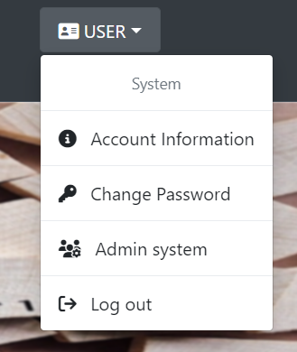

Figure 11. When logging in successfully

When logging in successfully, there will be a separate task menu here, it is available as information for the account, change the password, if it is an admin account, there will be a path to the admin page here, and finally log out.

In the order we'll introduce the account information, and here are the details of the account information page. It is designed in the form of a small card with a picture, a representative of their username, some contact information, and in addition, there are 2 small functions attached to the support history and editing personal information for the account.

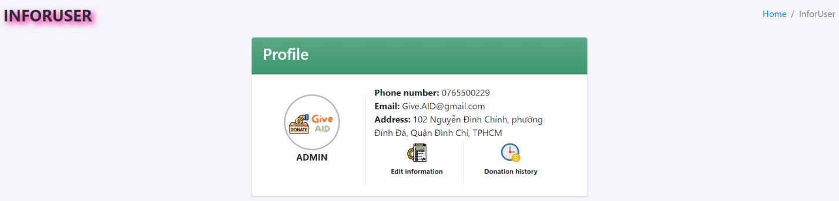

Figure 12. Image of the account information page

The function of editing personal information clicking on it will display a modal in which there will be relevant fields for us to change, be able to update the new avatar some information displayed in addition to the person information card box.

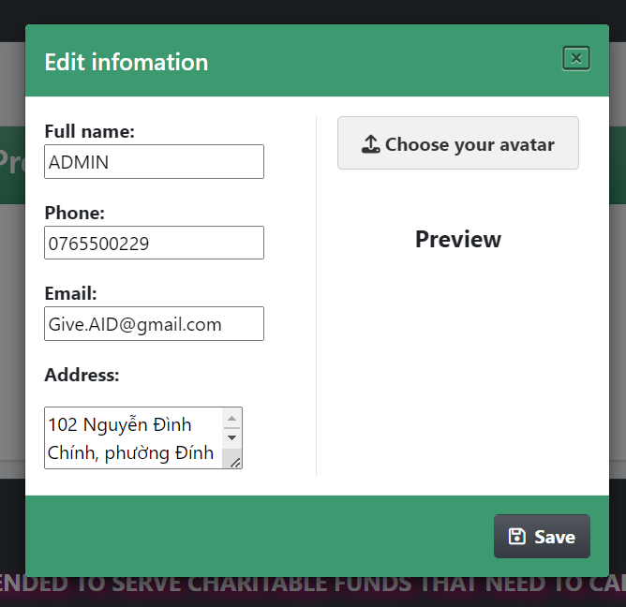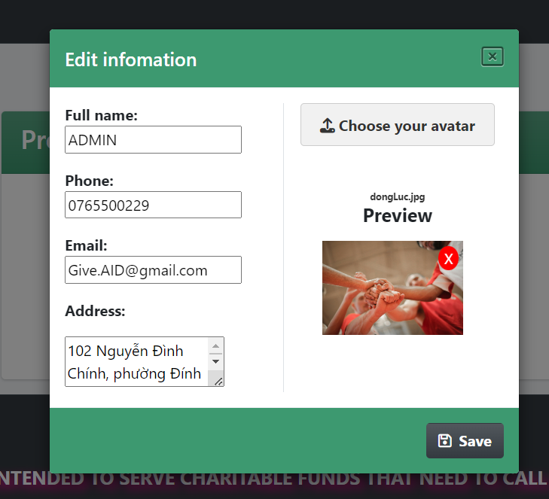

Figure 13. Images when using the information change feature

The other function is the function to review the history that has been advocated for the website. Users can review their donation history here, there will be information such as the title of the article, the amount of money and the time they have donated. If they want to see a strange post, clicking on the article name will take them to the page of the post they've supported.

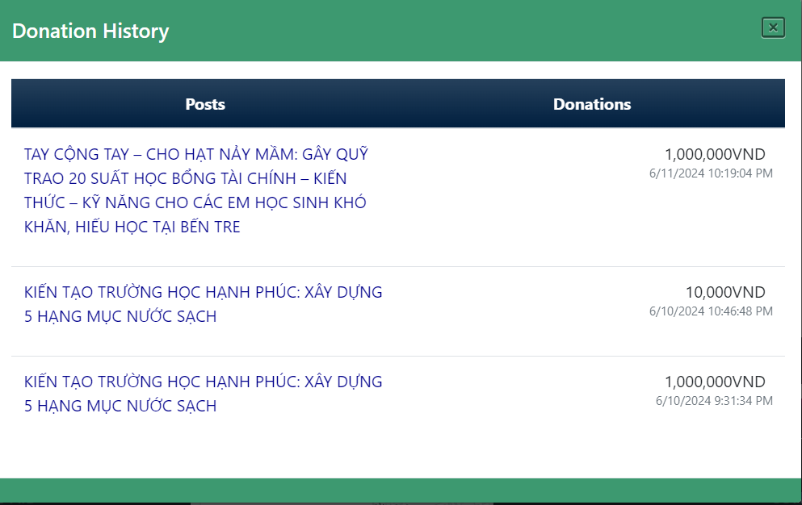

Figure 14. Review your support history

This is a small part of the usable part of the user interface, now we will go to the ADMIN page with the ADMIN account to do the main operations of the website.

III.ADMIN

The admin interface page is on the main page so that the data is filtered by month or year of each different type of item, and there are 2 more charts by article type, 1 is filtered by the total number of posts by article type, the other will be the total amount of donations by article type.

Hình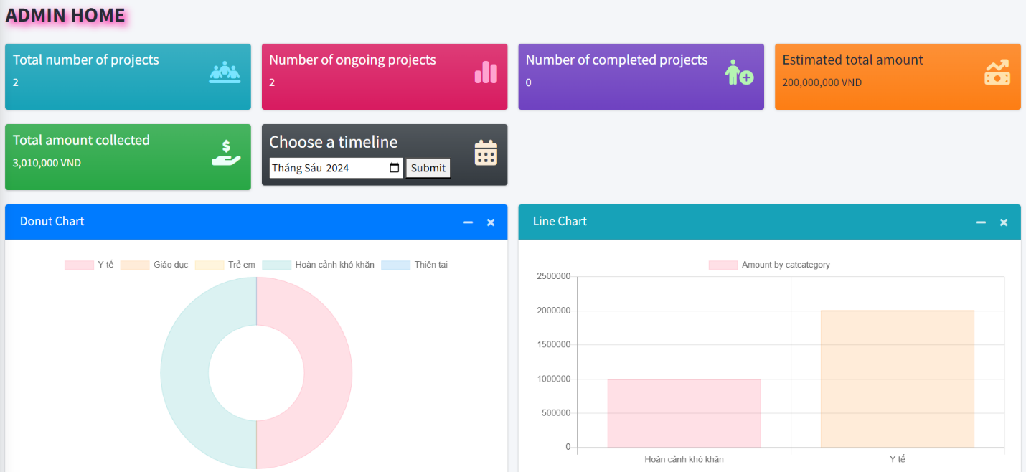 15. Giao diên trang chính của trang chủ

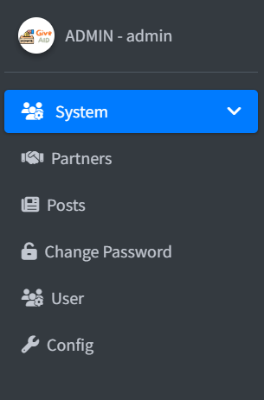

Figure 16. Set of menu operation buttons in admin

Going through each menu we have, first of all, if we want to have an article, we have to create a partner because they will be the contact to collaborate on the website by creating a call to action.

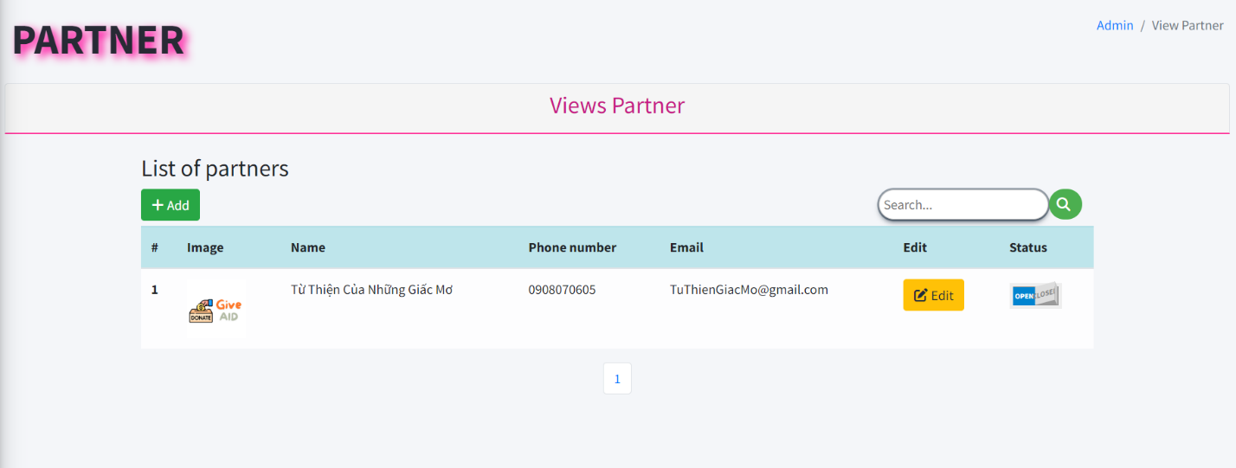

Figure 17. The interface of the partner function when they are created

Briefly introducing this function page, it will be a list of partners, here there will be a number of buttons and functions that can be manipulated, the first in the left corner we have an add button to create a new partner, a search bar to search for the name of the partner quickly, and the edit button is located in the partner list to modify the information according to their requirements, and there is a status update button. First, we're going to create a new start by clicking the plus button in the left corner.

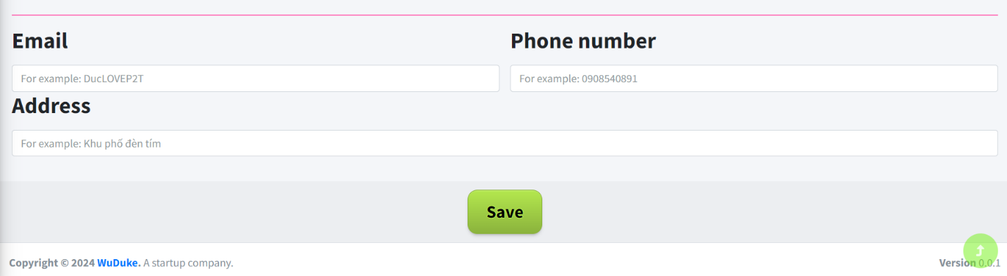

Figure 18. Add a new partner

Here, I should enter all the information for a partner to create a new one successfully, and when we successfully create it, we return to the partner page, it will appear in the list.

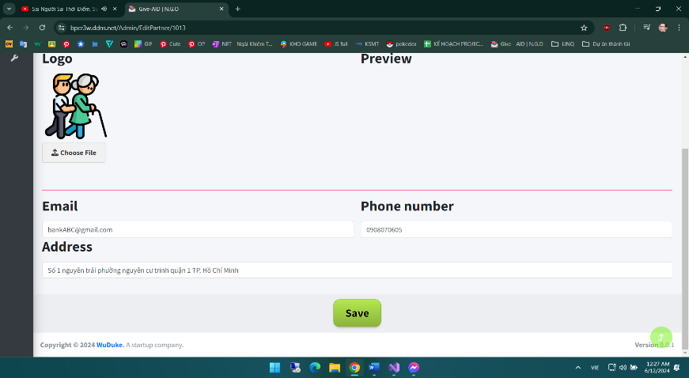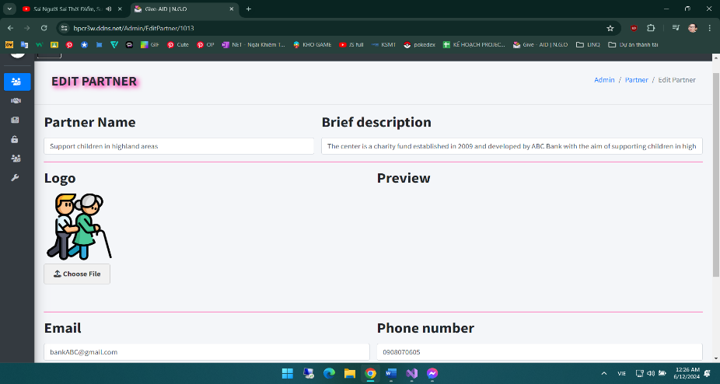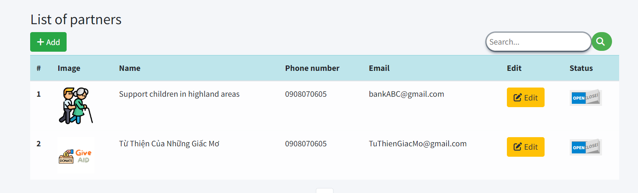

Figure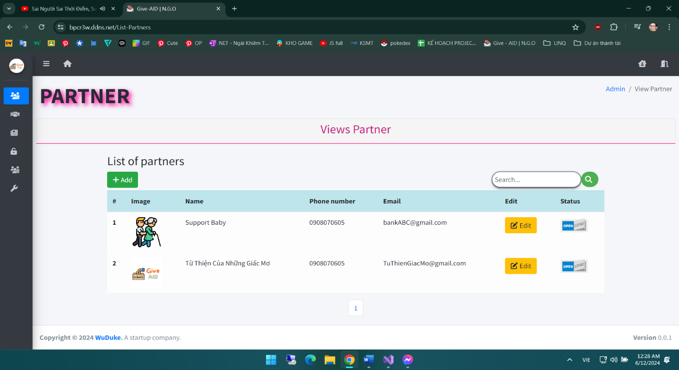 19. A group of photos describing the process of wanting to re-edit information

New and edited pages are taken advantage of the common use of the initial creation of new forms, the field will take the data according to the id and transmit it to the corresponding input cells so that we can edit it, in addition, the search box can be used by the name of the partner to filter the results. There is also a status box to help me close this partner. Close here, the user partner page will no longer show partner information there.

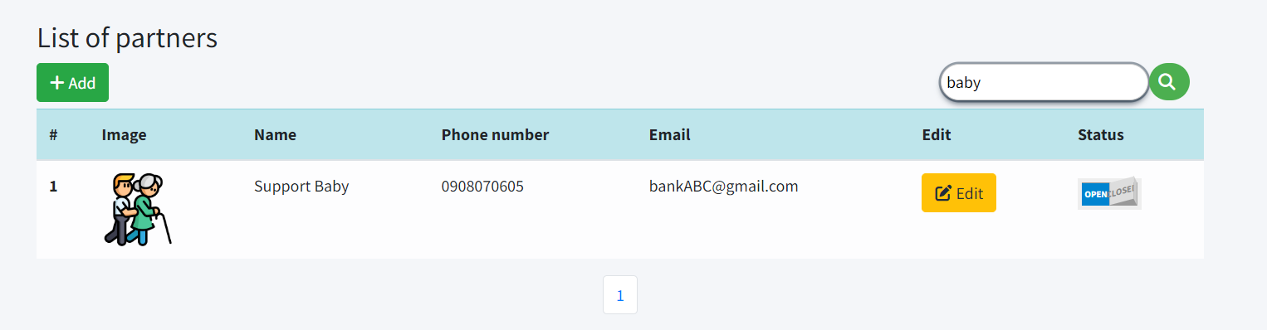Figure 20. Search by name

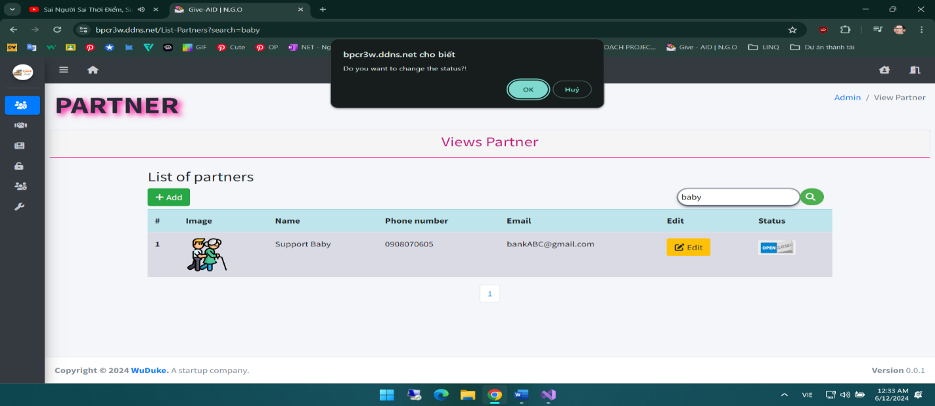Figure 20. When clicking the status button

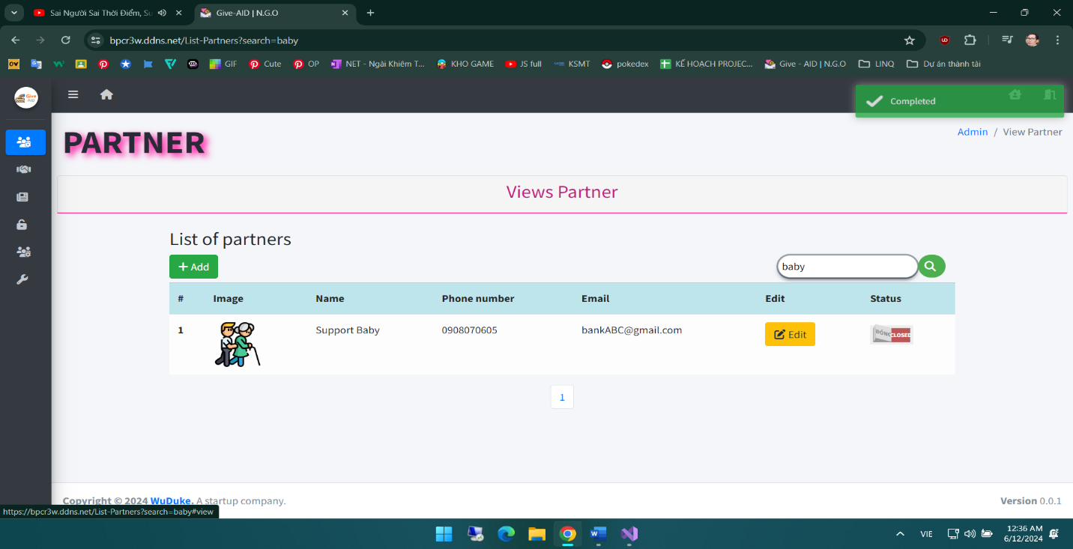

Figure 21. When the status changes

Figure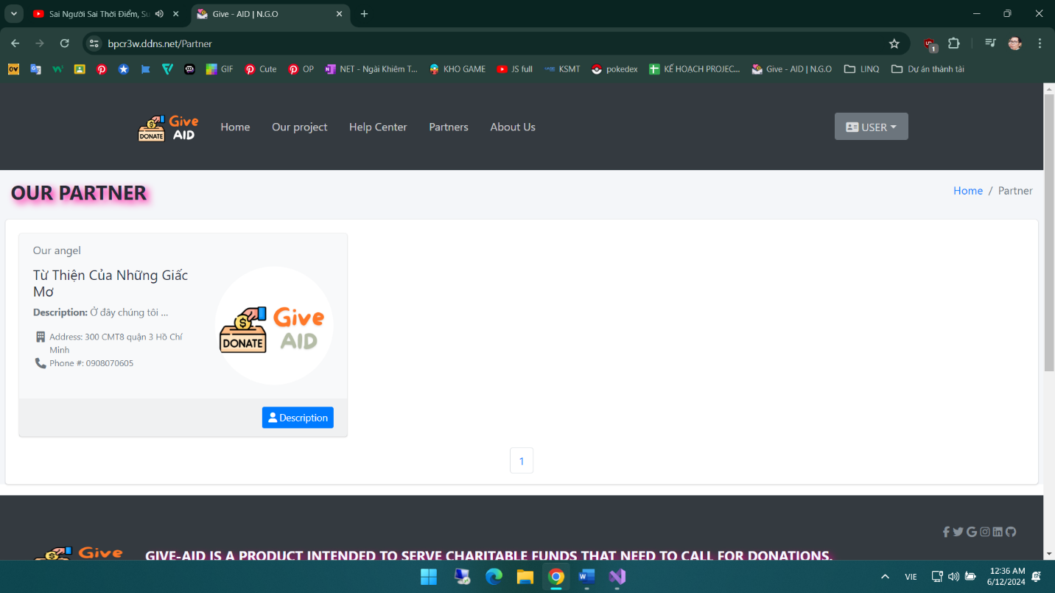 22. Partners are not shown here when the status is closed

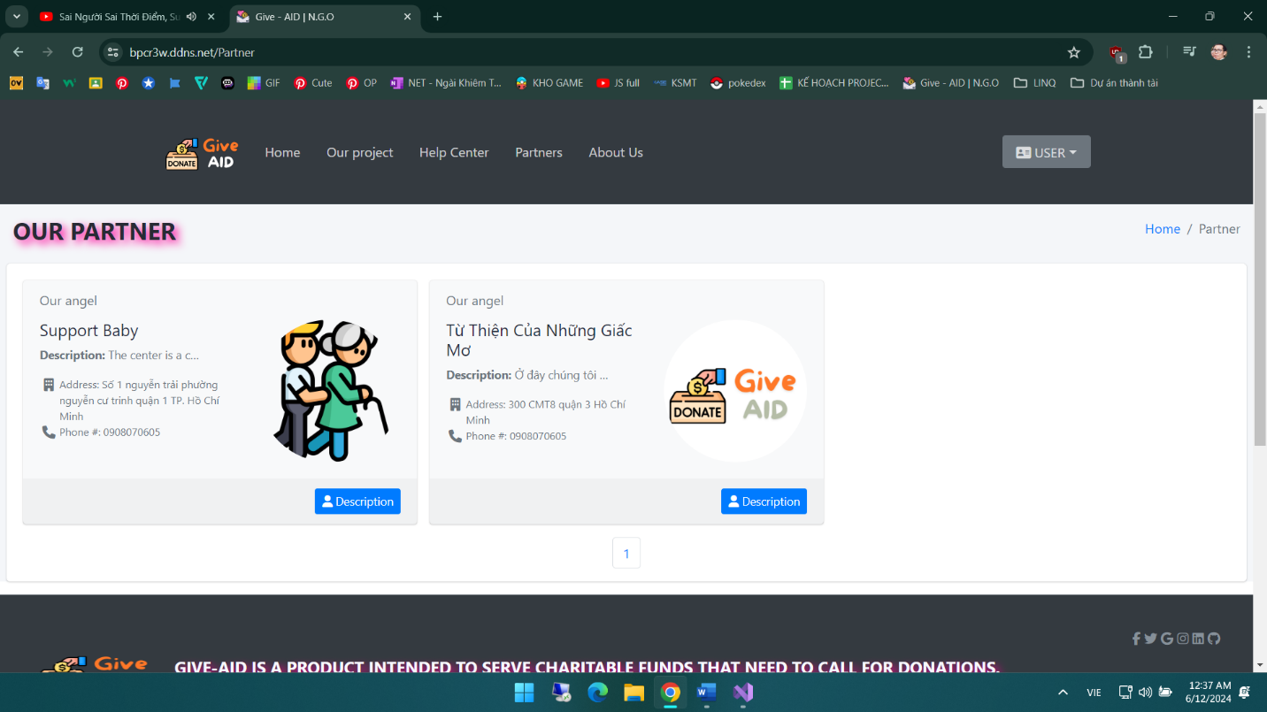Figure 23. When a partner has an open status

Now that we have a partner, we can create an article, first of all, we will go to the posts function box, design an interface similar to the partner page, only the difference is in the goal column and donation, there will be an additional filtering function according to the increase or decrease value for the money item of the article. To create a new article, we click on the add button, at this time it will display a news template for us to enter, enter full information according to the form will create an article in the article list, in addition, the reason for creating a partner is because the partner will be the one to provide information for these articles, Create a new partner First, we have partner information to choose from, in addition, you can also choose the type of article to tag it, if you want to create a new type, you can add it directly in each new addition or edit. The most important thing is to adjust the target amount and expiration time for the article, which will be important information for the article. And here I will do the operation of posting a new article.

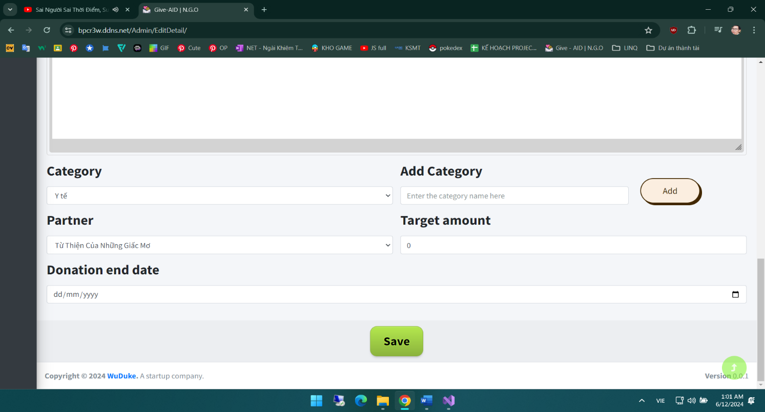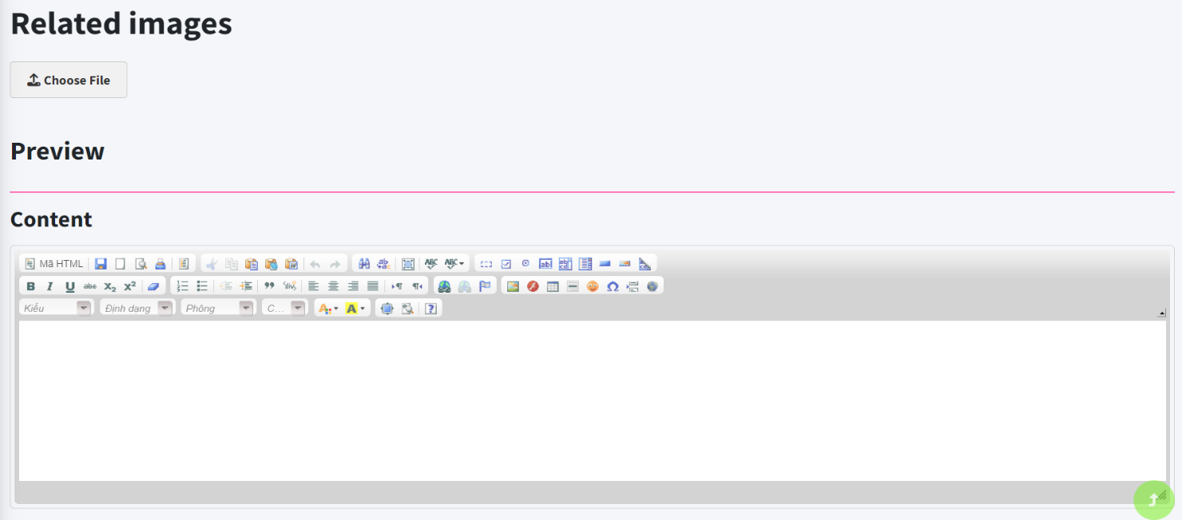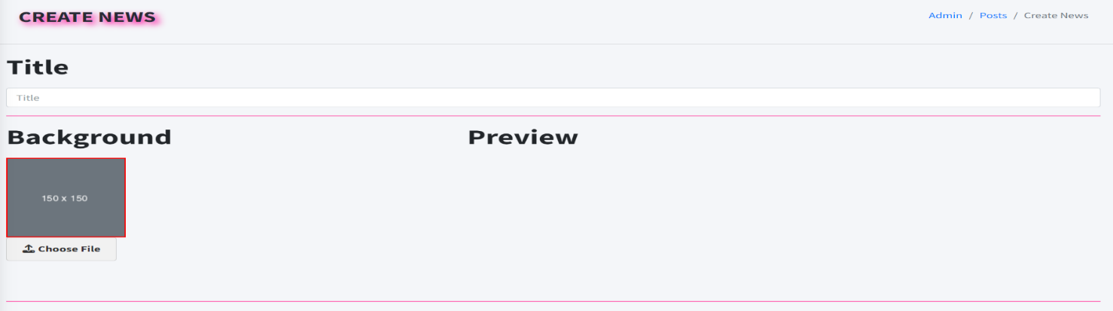

Figure 24. Information to enter to create a new article

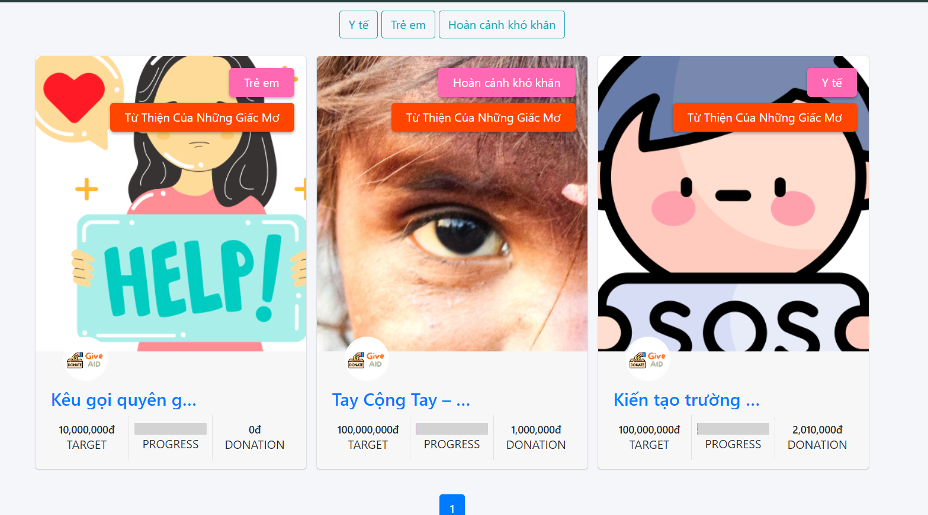 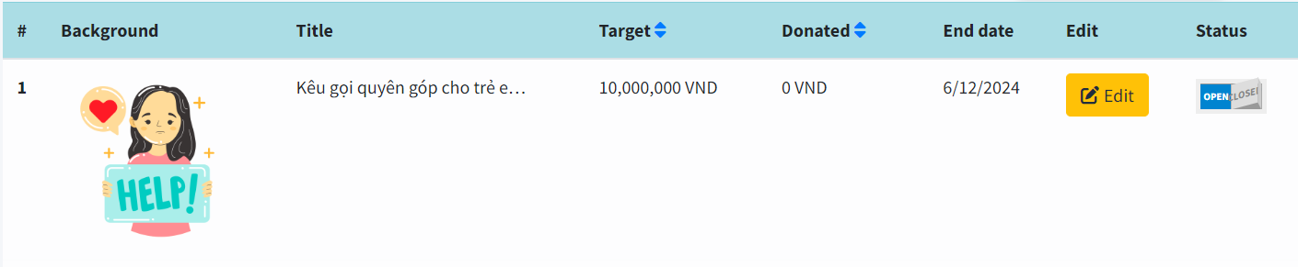

Figure 25. When a new article is created successfully

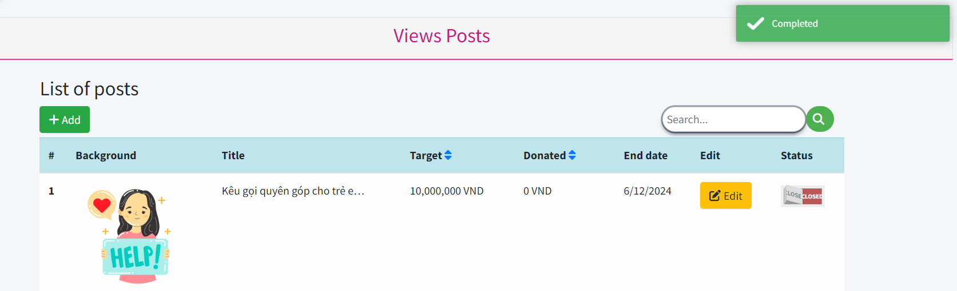

Figure 26. Update the status of an article

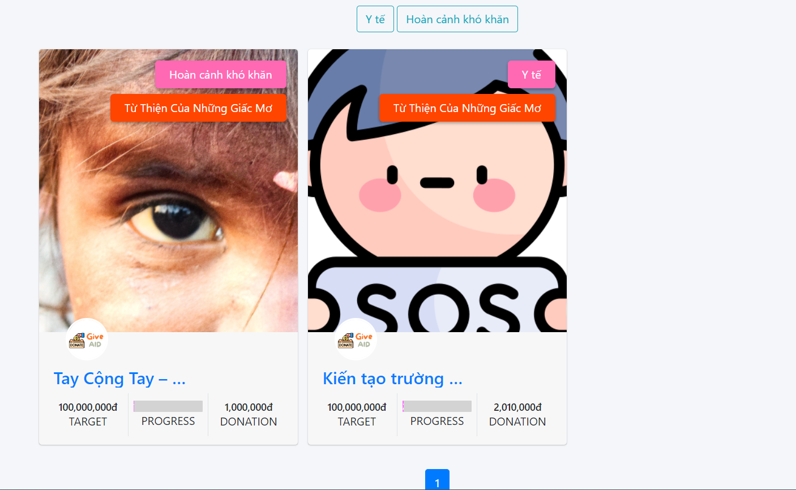

Figure 27. Posts with a closed status will not appear on the user's main page

Next, in the menu bar of the admin, we have a password change section outside the user page, there is also a place to enter the password change page, here just enter the current password and enter the new password and enter the confirmation again to change the password.

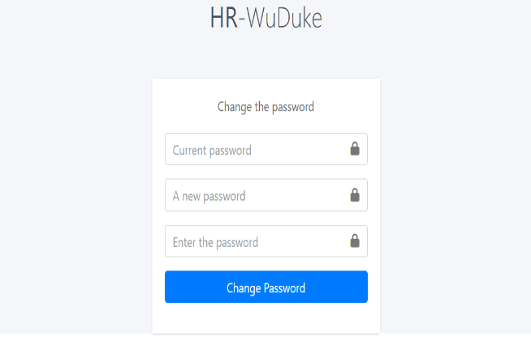Figure 28.User Password Change Page

The last function that the ADMIN has is the configuration, which can help the user change some information. Our team currently allows users to change contact information, short descriptions of the website, change the logo of the slide image that runs on the user page, basically the whole team can only update like that, because the time is not in time, but the whole team can demo it as a seasonal interface change, but wait for it to be completed, this website will be Although it is very unfortunate, the whole team tried their best to bring the best.

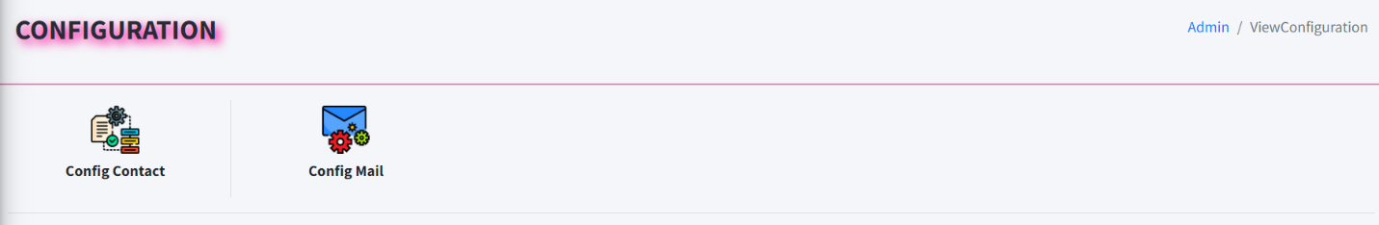Figure 29. Menu in the configuration function

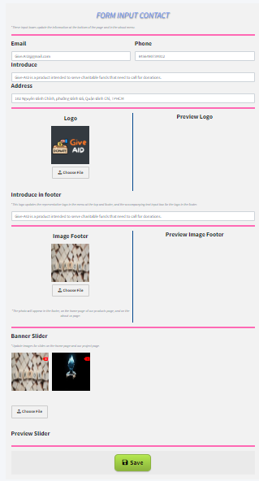Figure 30. Form function to change the contact information image for the website

The other function is to configure email, this email allows the web system to send invitations to join via the shareposts function available on the user page. It will have the full configuration for a mailing email that a website should have from selecting the smpt method, port, input email username and password, and also a check box for using SSL if it is a business mail servel.

Figure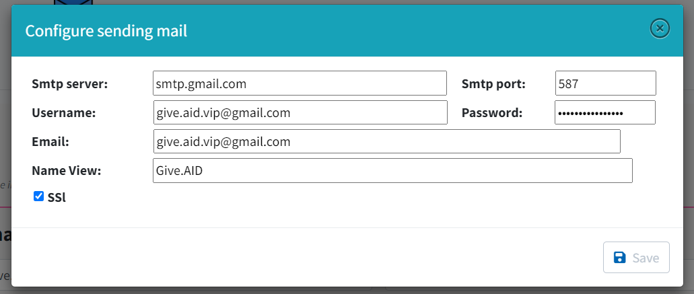 31. Full email configuration for an email used to send mail

If everyone tests, they can use the settings to be ready like this, just change everyone's email and password, if you use gmail, we need to go to the gmail account, turn on google's 2-step authentication, and then search for the application password section and create 1 to enter in the password box, Due to Google's privacy policy, Gmail is not allowed to use their normal login password, and business mail or servel mail will not need this operation.

* So this is the end of the process from home to login and to admin are the first steps to create an article for users to view and use.

Going back to the normal basic user if you are a newbie and want to use the website, if we don't use features such as sharing articles by email or donate, we can still see the article, just click on the title on each card of the article, it will lead us to the detail page here. more complete and clear information as well as the content of the appeal article, see the support list of accounts that have supported the article, in addition to using the feature of sharing the post on social networks such as Facebook.

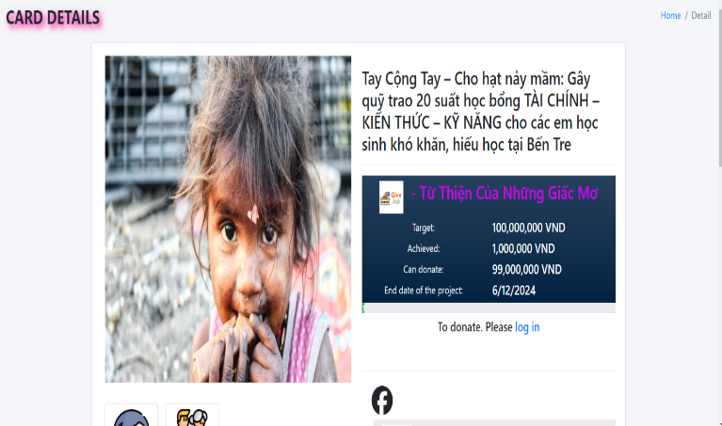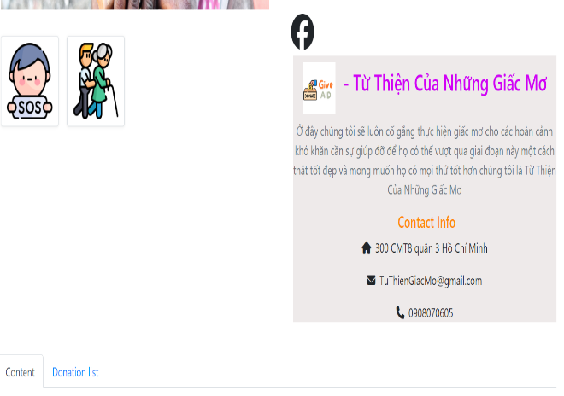

Figure 32. Detail pages for articles

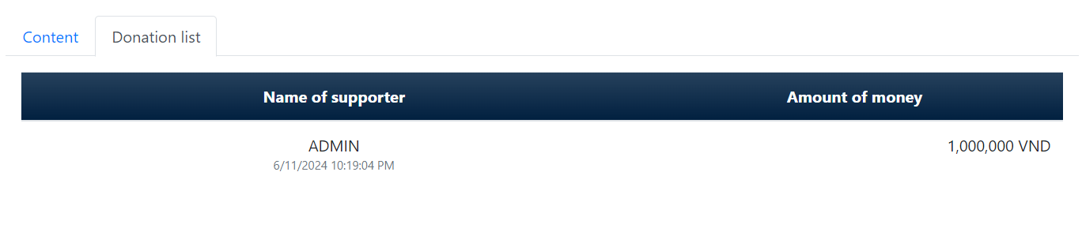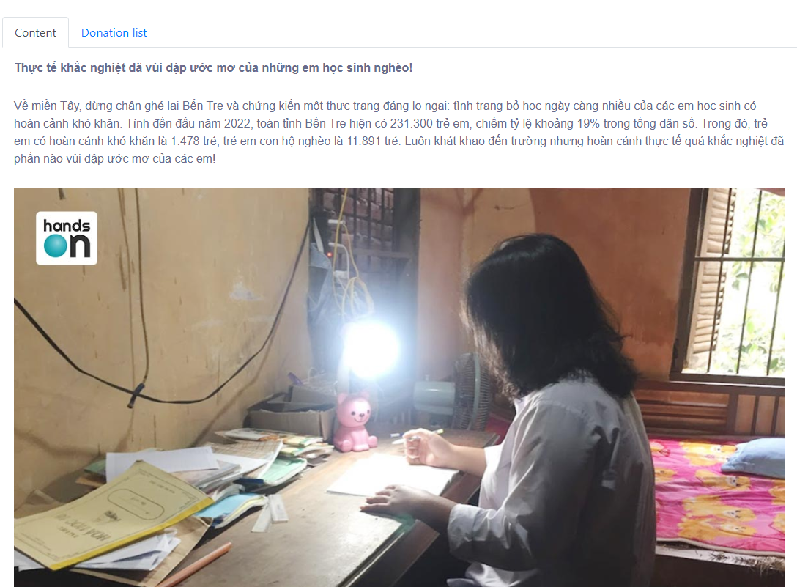

Figure 33. Content tab and donation history of users for posts

In the information box of the article, there is a text that if you want to support, please log in, explain a little, to use the feature, donate and share posts by email, you need to log in. And in addition, if an article expires, even if you are logged in, you cannot donate or share the article via email, only the article with a deadline can be manipulated on it. And in addition, when clicking on the word log in, it will take us back to the login page if you don't have an account, you can completely create a new one, then log in and go back to the article to choose the 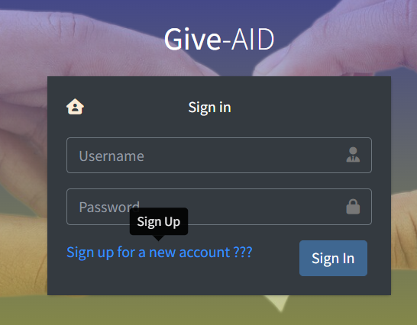article you want to support.

Figure 34. Click this text to go back to the new registration page

Figure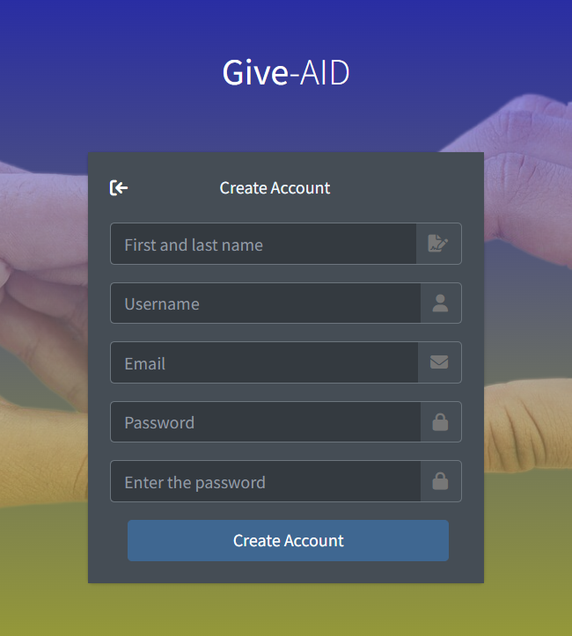 35, New registration page, always remember to enter enough information

Here to create a test account, I will leave the account and password as test and 12345678. And that's it, log in successfully and use the detail page feature. And one thing to remember is that the user password must always be 8 characters long.

Log in to the article's detail page again, select the article you want at this time, here there will be 2 functional buttons, which are support and share the article, the first is about the support button. We click to select the price or enter the number we want, here you have some ready-made prices, then click the payment button, and if we don't want to show the donor's name, we can click on the checkbox next to it to donate anonymously. When you click pay, we will be redirected to the VNPAY page, which will be the partner that we use to pay online for all users. Currently, vnpay is used on VNPAY's sandbox environment, we enter the payment card information successfully, it will give us a notification result and take us back to the website so that we can continue to read or support.

Figure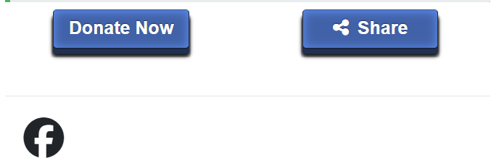 36. The function button appears after logging in to the

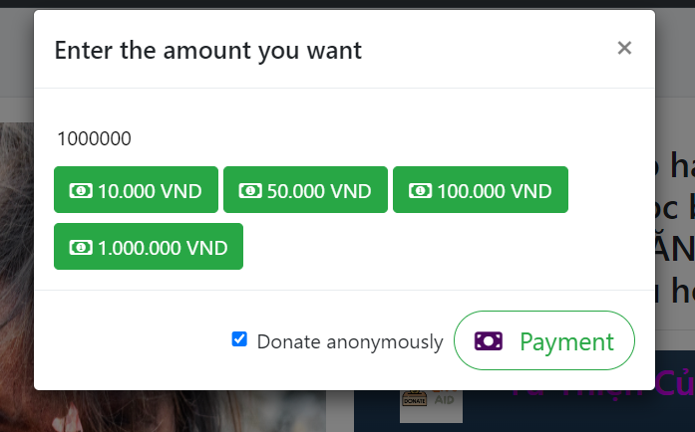Figure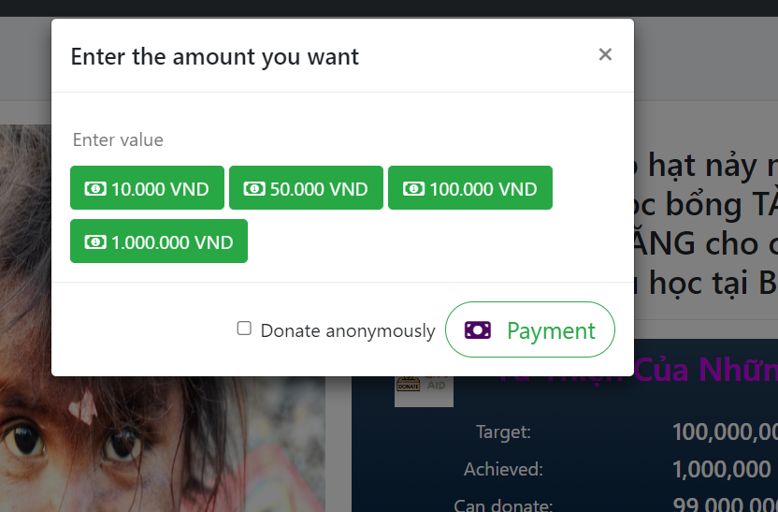 37. When checking the donate now box, the input capital will be displayed

Figure 38. Choose to donate anonymously if you don't want the donor's name to appear

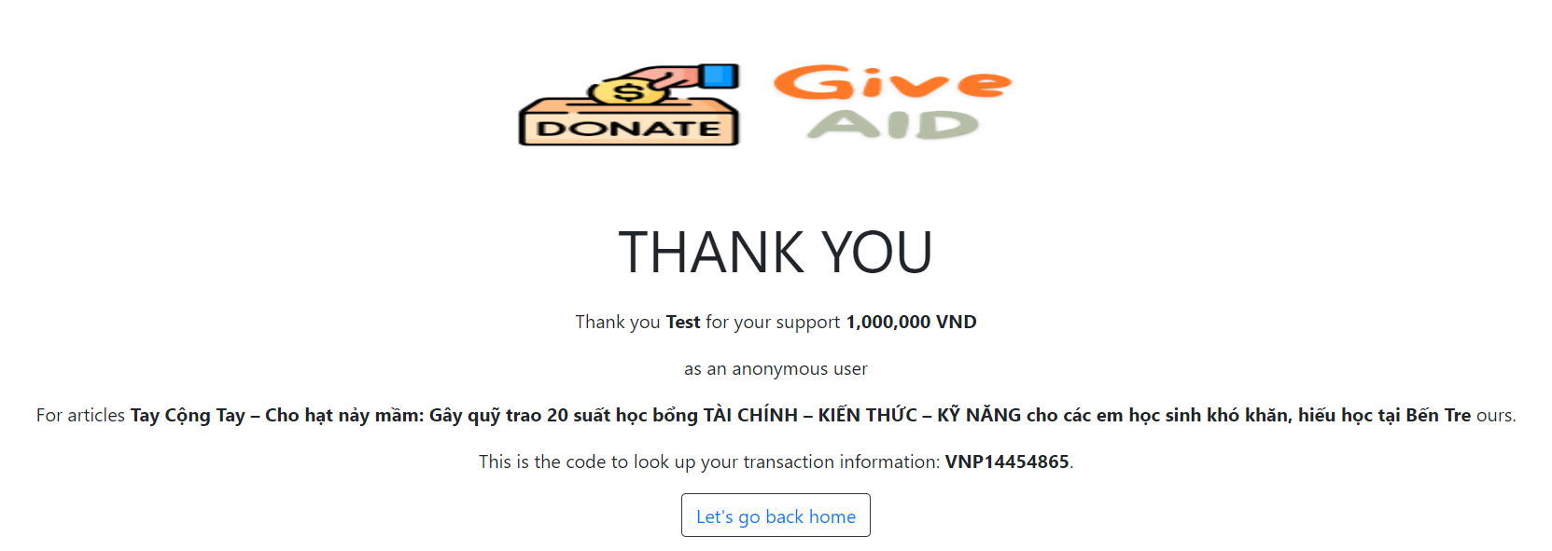

Figure 39. When the payment is successful, there will be a thank you note and a button to return to the homepage to continue using the service

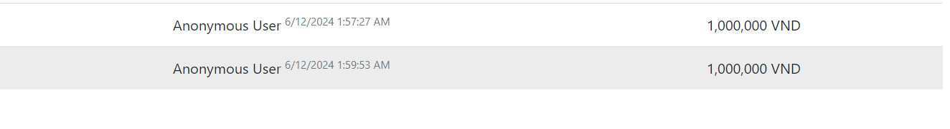

Figure 40. When donating anonymously, your name will not be displayed here

Next will be the share article by email box, when you click on the modal appears for us to enter the mail, you can enter the email of the person you want to share here, if you want to send it to many people, you can use a comma or enter after each entry to enter multiple emails, And there is a limit of only sending to 6 people every 5 minutes, because in order to avoid being spammed by mail leading to Gmail considering the account as sabotage, you can no longer send messages from this account.

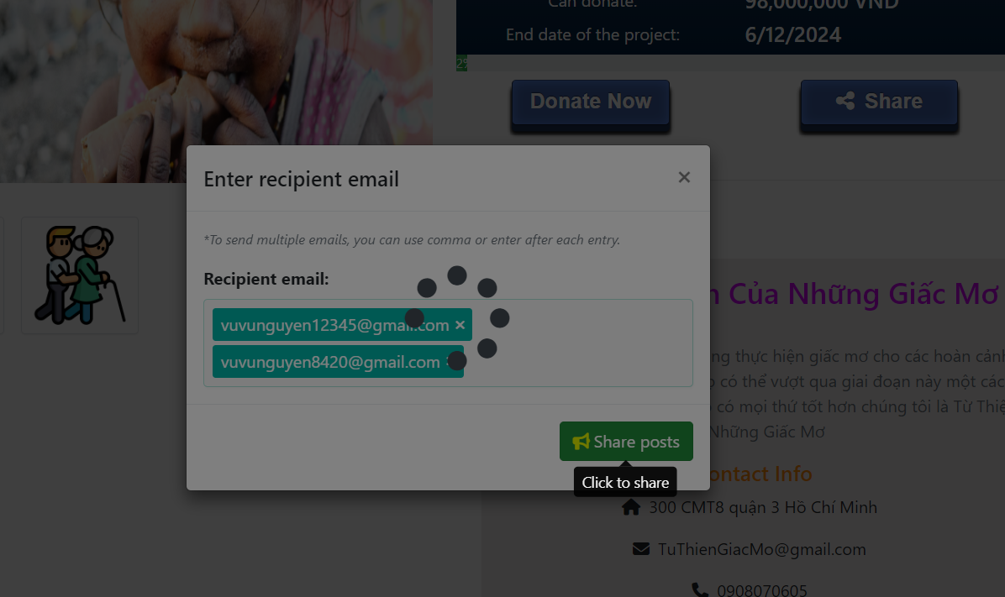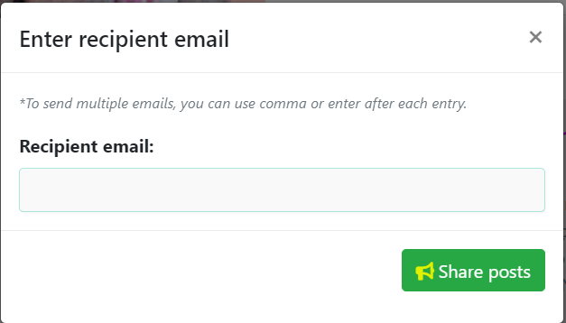

Figure 41. Process for sharing posts via email

Figure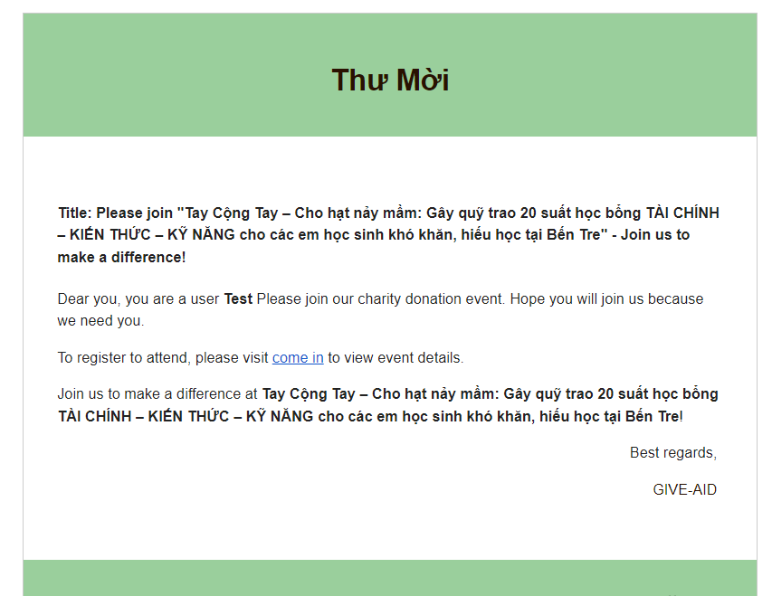 42. Mail when successfully sent to the recipient

The rest here will be the feature of sharing posts via facebook social network

Then when you click on the icon, it will pop up an article sharing window, it will take the information of the article to make a share, the feature of facebook requires us to have a host to use, here we do to have a web host to be able to show people this feature, If you use localhost, you won't be able to use Facebook's home features

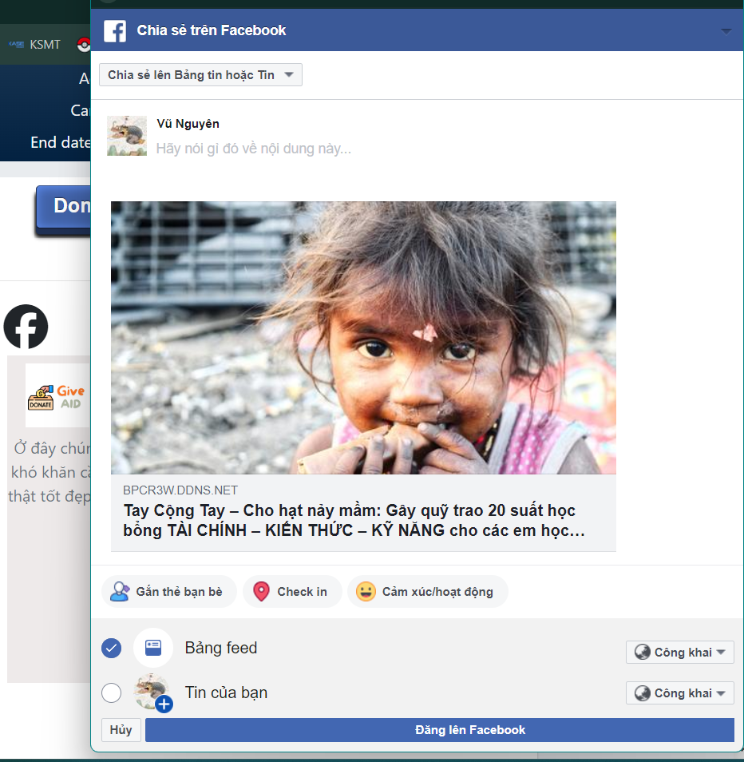

Figure 43. Share posts to facebook

And that's the whole feature that from viewing posts created by users to inside the ADMIN operating the website, in addition, there is still one more feature in the admin that will be the last of this website, which is user account management. It is impossible for the account to post alone throughout the time of using the web, in the future, if the user buys this product to use, they will recruit someone as an employee but cannot assign the admin account to them, the best solution is that we will make a title for the user account, there will be 2 titles: USER is the person use normally, and the second one will be a MOD, the person who has this account can enter the admin page to create a new partner, as well as create a new article, and the rest of the functions that the admin can use, the MOD will not be allowed to use, in addition, this account management feature of the admin can ban the account, A unlock for them, because they will not know, for example, if they are blocked by a certain account to create spam and miscellaneous information, blocking will be the most reasonable solution before dealing with other situations.

Figure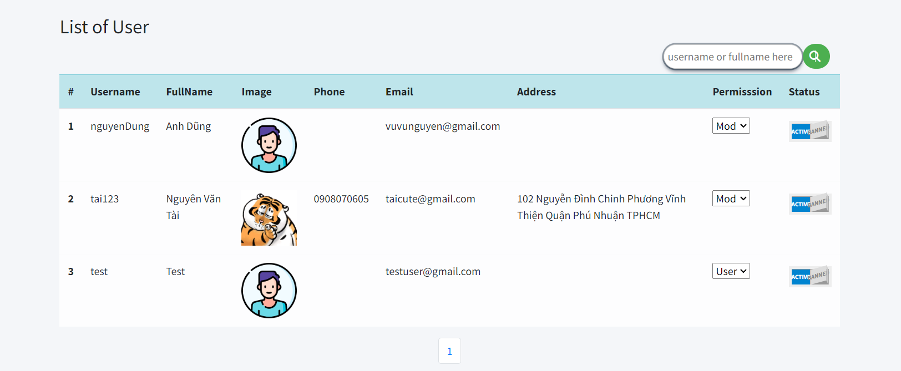 44. User Management

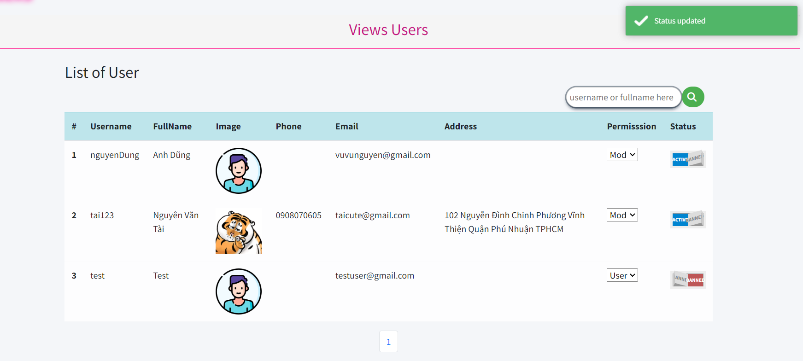

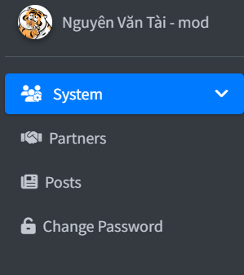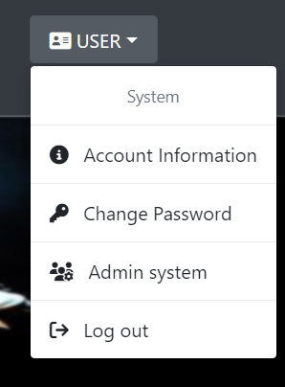Figure 45. Violating Accounts Board

Figure 46. MOD accounts are allowed to post news and create new partners without admin page

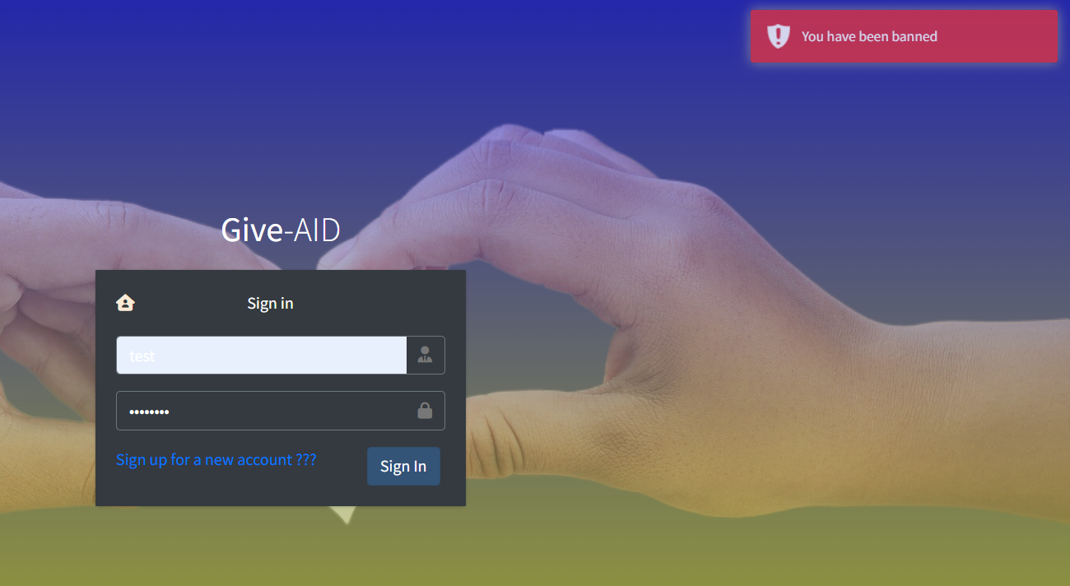

Hình 47. Một tài khoản bị cấm ở đây là tài khoản test theo hình 45

Database

This is the database model that the team made and created to handle the functions contained in the website

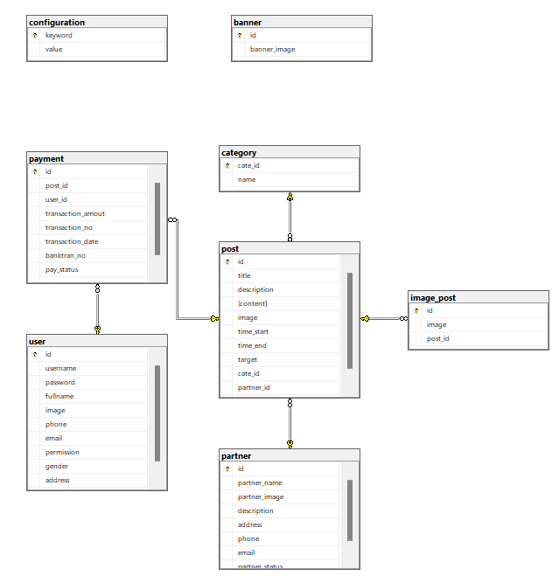Figure 48. Database model

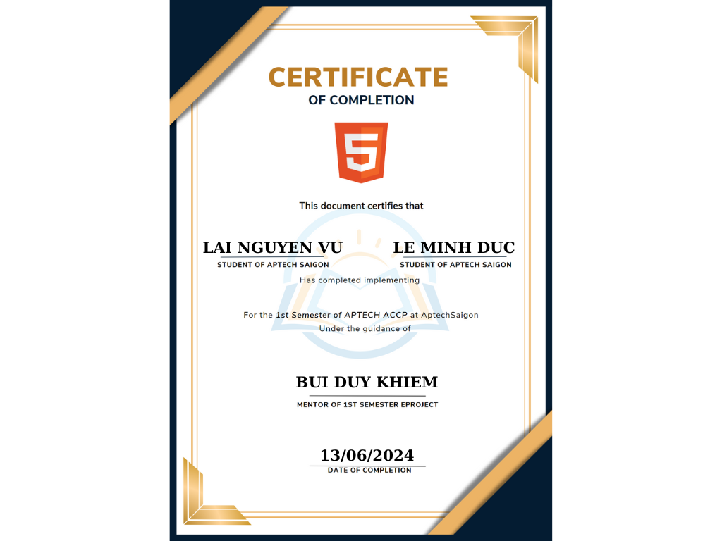

Figure 49. Happy Medal Photos

And at this point, all the functions of a website that we have been and can do, thank you for reading every detail attentively. I would like to send some account information and some resources to use the product experience

Admin account: minhduc

Dense stitching: 123

VNPAY test card:

Bank: NCB

Card Number: 9704198526191432198

Cardholder's name: NGUYEN VAN A

Release date: 07/15

OTP Password: 123456

Thank you APTECH for creating a learning environment full of quality training and professional dedication for APTECH students, I am very happy to accompany APTECH in the past time, Thank you Sincerely Thank you